

**BRACT’s**  
**Vishwakarma Institute of Information Technology  
Department of CSE-AI**

(An Autonomous Institute affiliated to Savitribai Phule Pune University)



# Lab Manual

Data Science and Machine Learning

**Submitted by,**

**Vaibhav Vinod Chavhan**

SY

Semester II Academic Year 2023-24

**ASSIGNMENT NO: 2**

**Problem Statement -**

Perform the following operations using Python on the data sets:

a) Compute and display summary statistics for each feature available in the dataset. (e.g minimum value, maximum value, mean, range, standard deviation, variance and percentiles

b) Data Visualization-Create a histogram for each feature in the dataset to illustrate the feature distributions.

c) Data cleaning, Data integration, Data transformation, Data model building (e.g. Classification)

**S/W Packages and Libraries used:**

For the following assignment, the interpreter used was Google Collab and the Primary Library used was-

* Matplotlib: Matplotlib is a versatile plotting library in Python, offering a wide range of visualization capabilities, including histograms for illustrating feature distributions.

**Theory-**

* For Computing Summary Statistics:
  + Utilize libraries like Pandas to load the dataset into a DataFrame.
  + Use Pandas' describe() method to generate summary statistics such as minimum, maximum, mean, standard deviation, variance, and percentiles for each feature.
* For Data Visualization - Histogram Creation:
  + Employ Matplotlib, a widely-used plotting library in Python, to create histograms for each feature.
  + Iterate through each feature in the dataset, plot its histogram using Matplotlib's hist() function, and customize the plot as necessary to illustrate feature distributions effectively.
* Data Cleaning:
  + Identify and handle missing values using techniques like imputation or removal.
  + Detect and handle outliers that may affect the integrity of the dataset.
* Data Integration:
  + Merge or concatenate multiple datasets if required for analysis.
  + Ensure consistency in data formats and representations across integrated datasets.

**Applications:**

* Descriptive Analysis: Summary statistics provide insights into the central tendency, variability, and distribution of features, aiding in descriptive analysis.
* Exploratory Data Analysis (EDA): Histograms visualize the distribution of individual features, revealing patterns, trends, and potential outliers.

**Limitations:**

* Data Quality: Incomplete or inaccurate data can lead to biased summary statistics and misleading visualizations.
* Model Performance: The success of classification models depends on factors like feature selection, model choice, and hyperparameter tuning, which may require iterative experimentation.

**Working:**

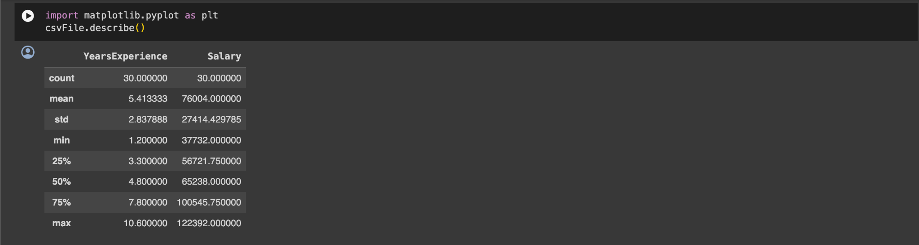

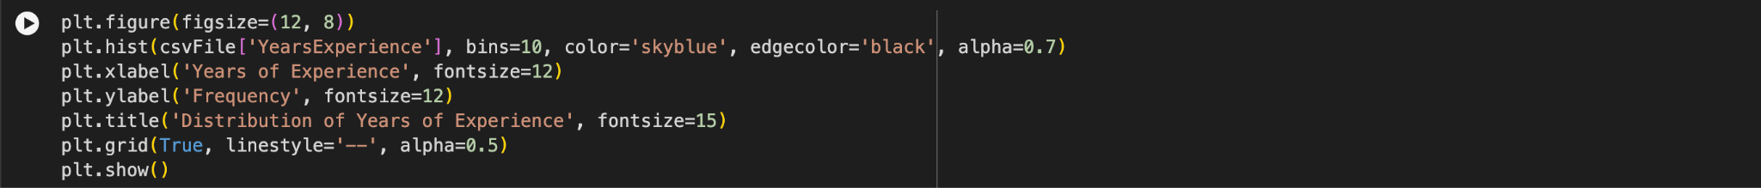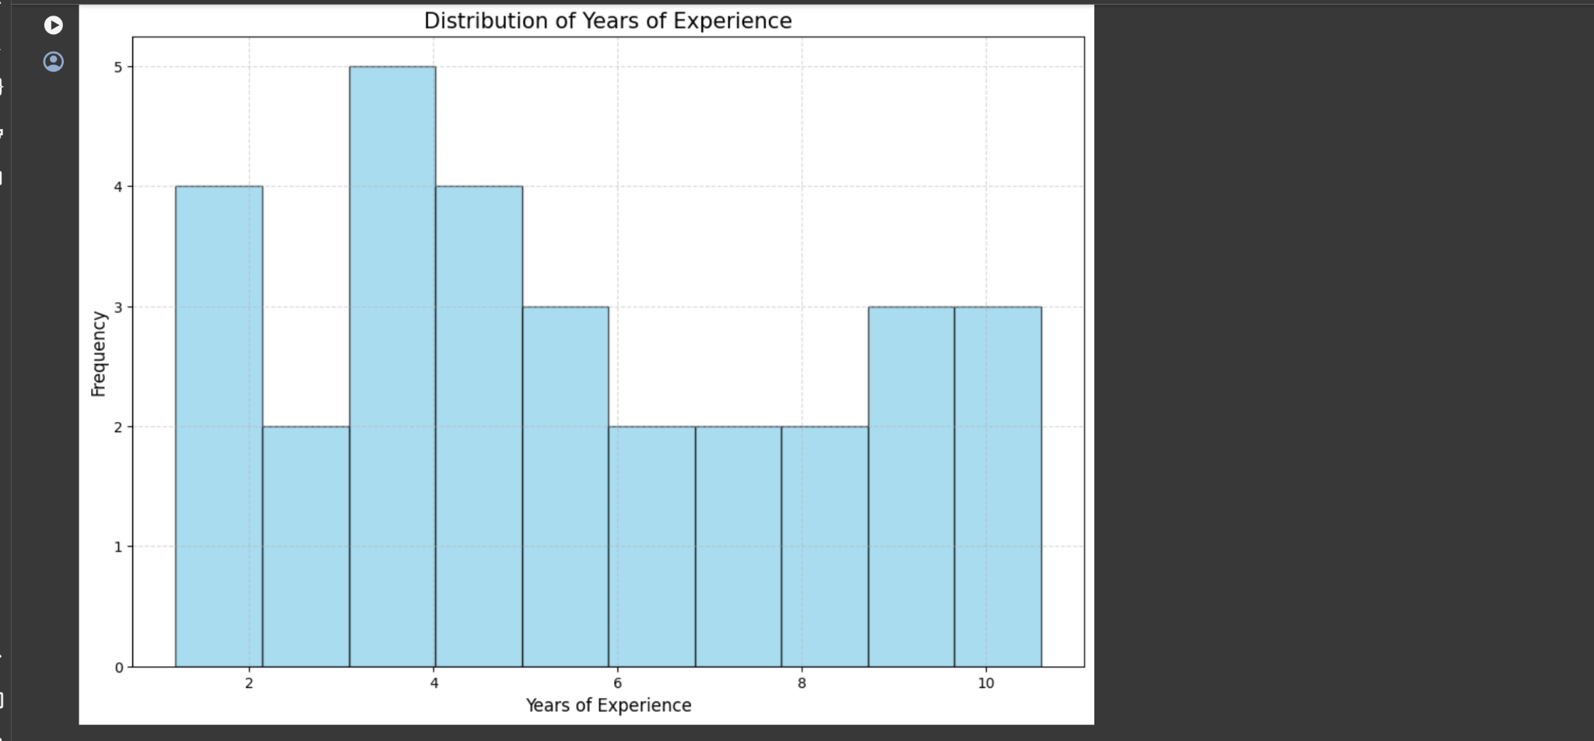

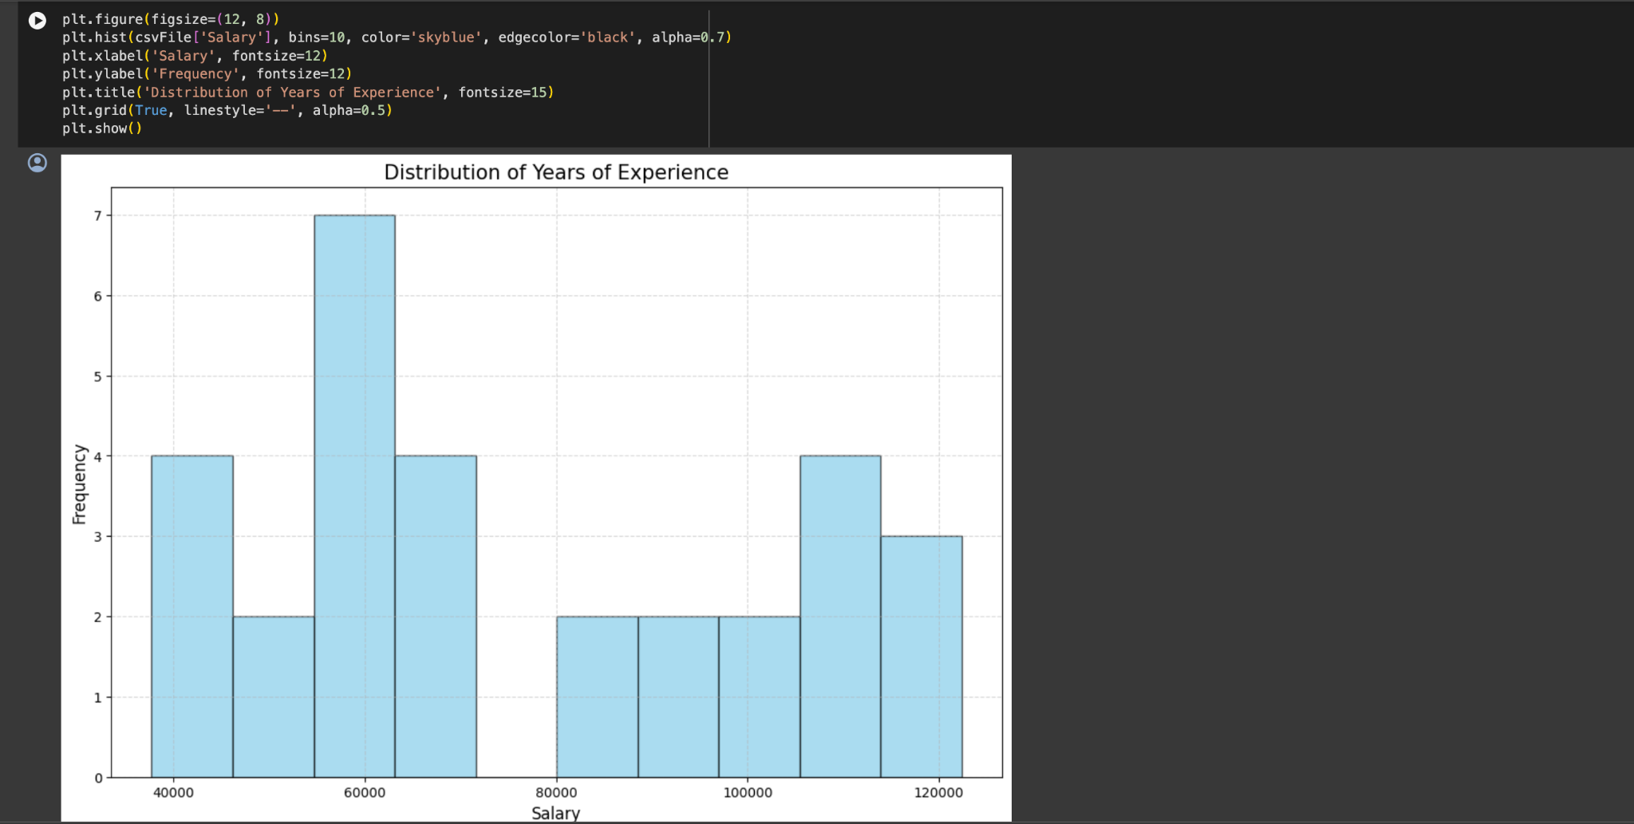

**Conclusion:**

By computing summary statistics, visualizing feature distributions, and executing data cleaning, integration, transformation, and model-building processes, it addresses essential aspects of exploratory data analysis and classification tasks. While offering valuable insights and enabling the construction of predictive models, it's important to acknowledge potential limitations such as data quality issues and computational constraints. Nevertheless, leveraging these libraries empowers practitioners to navigate datasets efficiently, derive meaningful insights, and develop robust classification models for informed decision-making.